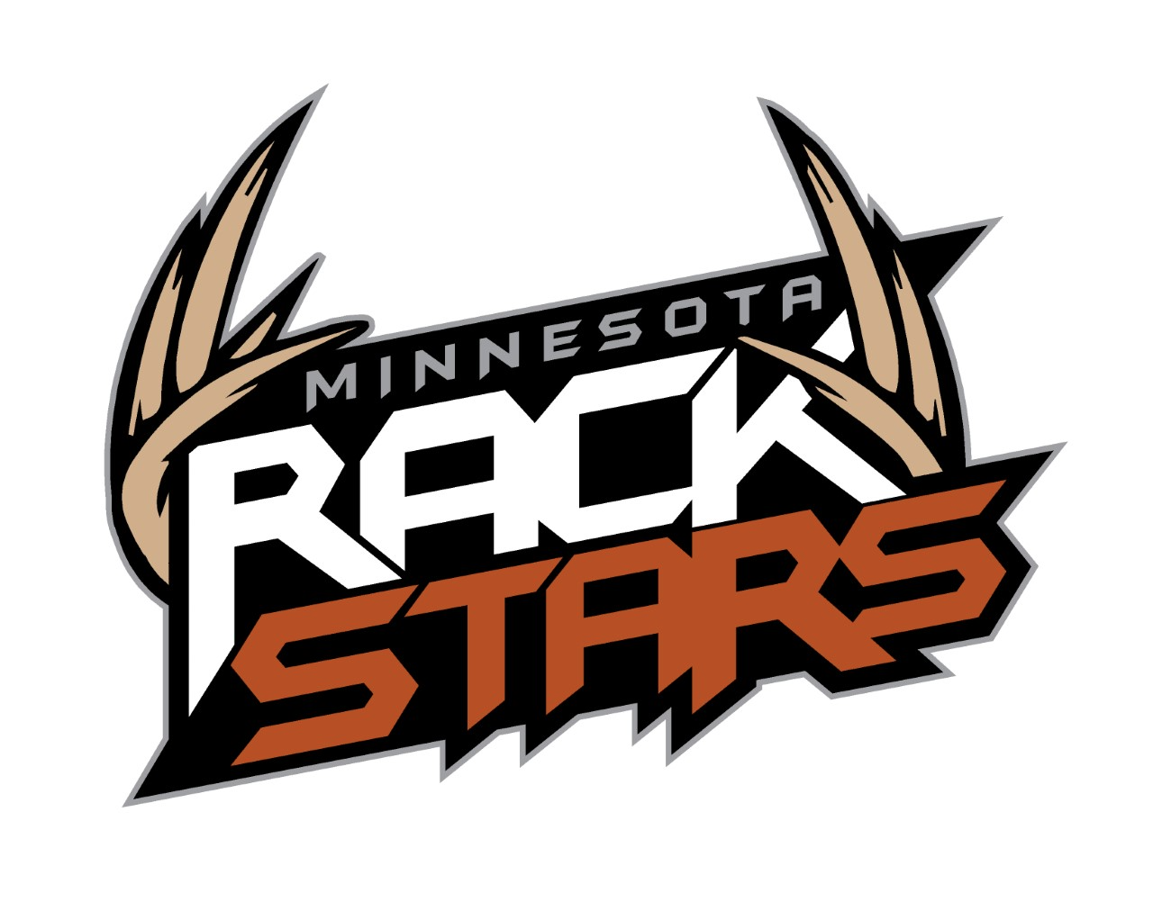

Minnesota Rackstars Pro-Staff Application

Thanks for having interest in becoming part of the Minnesota Rackstars Pro-Staff. We are looking for passionate hunters who love filming and sharing their experiences in the outdoors. Our focus is on educating and entertaining our viewers while promoting a positive and professional image of ourselves and the brands we represent.

Benefits of being on the Minnesota Rackstars Pro-Staff?
-Showcase your filming and hunting abilities to the outdoor industry and the world
-Meet and communicate with people in the outdoor industry
-Receive discounts on sponsored products
-Take hunting to a new level with new challenges

There are three levels when it comes to being on the Minnesota Rackstars Pro-Staff
Level 3-
-Unproven
-Little/no video experience
-Shares/likes some of the content on Minnesota Rackstars social media pages
-May have your video/photos posted on Minnesota Rackstars social media pages
Level 2-
-Proven abilities
-Has experience with videoing hunts and photography
-Shares/likes most of the content on Minnesota Rackstars social media pages
-Videos/photos may be posted to Minnesota Rackstars social media pages
Level 1-
-Has proven to produce quality hunts
-Videos and photos will be posted to Minnesota Rackstars social media pages
-Shares/likes all of the content on Minnesota Rackstars social media pages
-Shows professionalism in all areas and has the ability to represent Minnesota
Rackstars and our sponsors
-Level 1 will receive product discounts
**All applicants are to only show sponsors products in their video (Arctic Shield, Parker Bows, Easton Arrows, Antler King, Deer Stands Direct, Tactacam)
**All video must be in HD
**Send us a video introducing yourself and if possible some footage you have already taken (Youtube, Dropbox, Vimeo...)
Minnesota Rackstars Application

Name________________________________________________________

Address______________________________________________________

City, State, Zipcode_____________________________________________

Phone Number_________________________________________________

Email_________________________________________________________

What camera equipment will you be using?
________________________________________________________________

How many years have you filmed hunts?________________________________

Have you ever had a violation while hunting?_____________________________

What type of hunting will you be doing this year (bow, rifle, shotgun,
muzzleloader..) and where?
________________________________________________________________

Personal/Hunting Bio ________________________________________________________________
________________________________________________________________
________________________________________________________________
____________________________________________________________

Send you application to:
504 Lindbergh Drive South
Little Falls, MN 56345
jkahl7@hotmail.com

